1. Running Sum of 1D Array:
#code:
class Solution {
public int[] runningSum(int[] nums) {
for (int i = 1; i < nums.length; i++) {
nums[i] += nums[i - 1];
}
return nums;
}
}

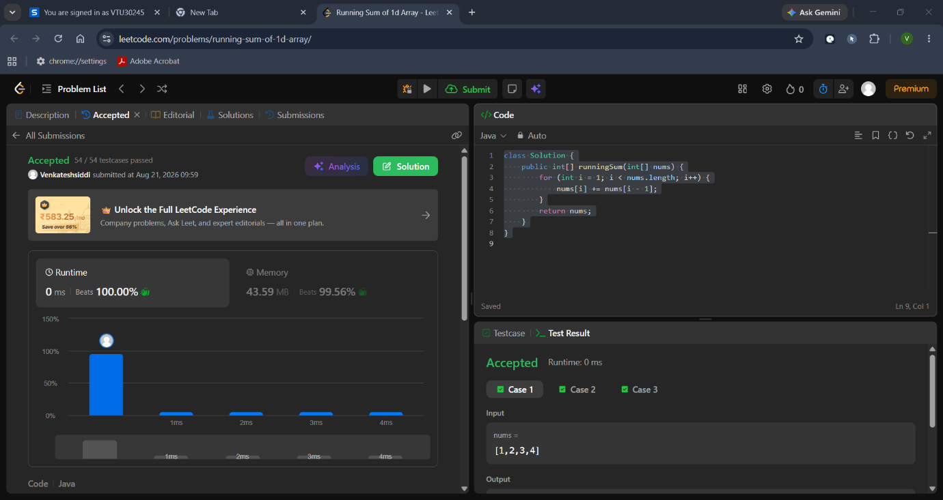

2. Richest Customer Wealth:
#code:
class Solution {
public int maximumWealth(int[][] accounts) {
int maxWealth = 0;

for (int i = 0; i < accounts.length; i++) {
int currentCustomerWealth = 0;
for (int j = 0; j < accounts[i].length; j++) {
currentCustomerWealth += accounts[i][j];
}
maxWealth = Math.max(maxWealth, currentCustomerWealth);
}

return maxWealth;
}
}

